  Group project-final documentation  Girlyy Games Development | Waiter training application  – For burgeraholics  Group 20  Almero Jansen van Vuuren – 35202734  Lincoln van Zyl – 35029617  Melissa Roodt – 33509735  Luc Bras-Nel – 37649523  Wilco Tromp – 34531033

Table of Contents
Physical Process Model 2
Database Schema 3
All SQL used: 4
Creating the Database 4
Employee Table: 4
Login Info Table: 4
Manager Table: 4
Training Template Table: 4
User Score Table: 5
Maintaining all the tables 5
Maintaining Employees Form: 5
Maintain Managers Form: 6
Maintaining Templates Form: 6
Training: 7
Querying the Database 7
Login form: 7
Maintaining Employees Form: 7
Maintain Managers Form 8
Maintaining Training Template Form: 8
Report Form: 8
Selecting Training Form: 9
Training Form 9
Maintaining a Child Entity 10
Reports Generated by the System 11
Report generated for the manager (filtered to only show memory trainings): 11
Report generated for the employee (Sorted descending according to date): 11
User Manual 12
Technical requirements 13
Getting the system installed 13
Launching the application 13
Manager 14
Logging in 14
Maintaining Employees 15
Adding New Employees 16
Deleting an Employee Record. 17
Maintaining Training Templates 17
Requesting Reports 19
Employee 21
Logging in 21
Using Training Tests 21
• Time training has a progress bar that shows you how much time you have left 22
• When submit is clicked then the score gets saved to a database. 23
Requesting Reports 23
Admin 25
Logging in 25
Dashboard 25
Maintaining Managers 26
Adding New Managers 27
Deleting a Manager Record. 27
Detail Dairy 28

Physical Data Model
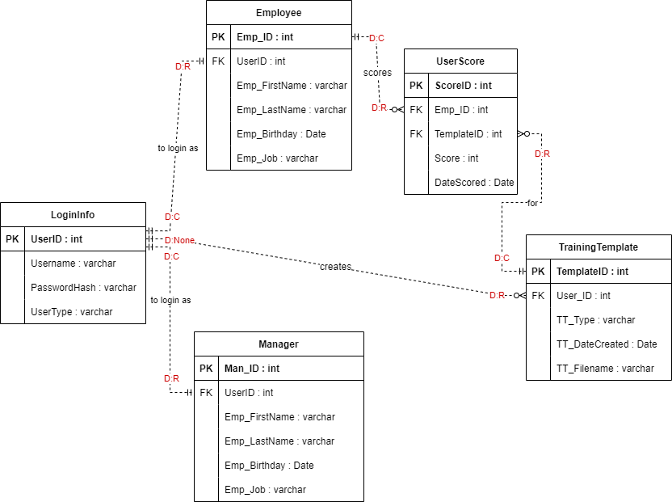

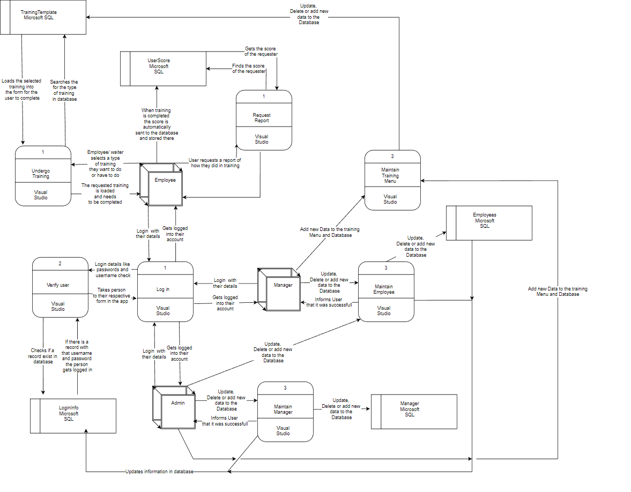
Physical Process Model

Database Schema
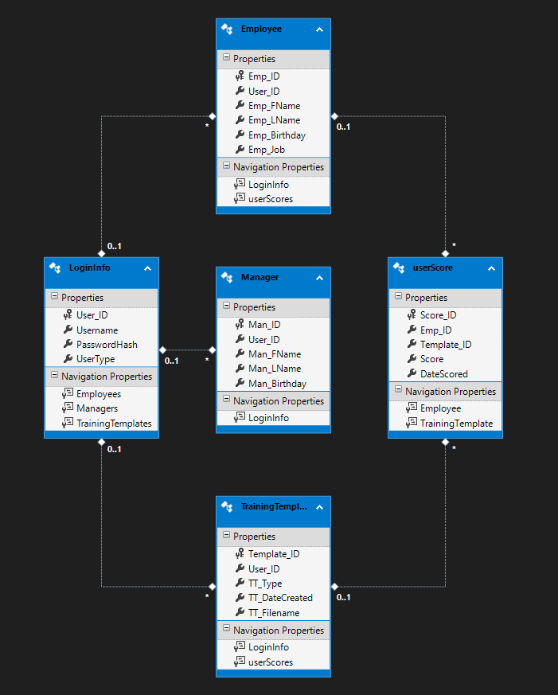

All SQL used:

Creating the Database

Employee Table:
CREATE TABLE [dbo].[Employee] (
[Emp_ID] INT IDENTITY (1, 1) NOT NULL,
[User_ID] INT NULL,
[Emp_FName] NVARCHAR (50) NULL,
[Emp_LName] NVARCHAR (50) NULL,
[Emp_Birthday] DATE NULL,
[Emp_Job] NVARCHAR (50) NULL,
PRIMARY KEY CLUSTERED ([Emp_ID] ASC),
CONSTRAINT [FK_Employee_LoginInfo] FOREIGN KEY ([User_ID]) REFERENCES [dbo].[LoginInfo] ([User_ID])
);
=================================================================================

Login Info Table:
CREATE TABLE [dbo].[LoginInfo] (
[User_ID] INT NOT NULL,
[Username] NVARCHAR (50) NULL,
[PasswordHash] NVARCHAR (55) NULL,
[UserType] NVARCHAR (10) NULL,
PRIMARY KEY CLUSTERED ([User_ID] ASC)
);
=================================================================================

Manager Table:
CREATE TABLE [dbo].[Manager] (
[Man_ID] INT IDENTITY (1, 1) NOT NULL,
[User_ID] INT NULL,
[Man_FName] NVARCHAR (50) NULL,
[Man_LName] NVARCHAR (50) NULL,
[Man_Birthday] DATE NULL,
PRIMARY KEY CLUSTERED ([Man_ID] ASC),
CONSTRAINT [FK_Table_LoginInfo] FOREIGN KEY ([User_ID]) REFERENCES [dbo].[LoginInfo] ([User_ID])
);
=================================================================================

Training Template Table:
CREATE TABLE [dbo].[TrainingTemplate] (
[Template_ID] INT IDENTITY (1, 1) NOT NULL,
[User_ID] INT NULL,
[TT_Type] NVARCHAR (50) NULL,
[TT_DateCreated] DATE NULL,
[TT_Filename] NVARCHAR (50) NULL,
PRIMARY KEY CLUSTERED ([Template_ID] ASC),
CONSTRAINT [FK_TrainingTemplate_LoginInfo] FOREIGN KEY ([User_ID]) REFERENCES [dbo].[LoginInfo] ([User_ID])
);
=================================================================================

User Score Table:
CREATE TABLE [dbo].[userScore] (
[Score_ID] INT IDENTITY (1, 1) NOT NULL,
[Emp_ID] INT NULL,
[Template_ID] INT NULL,
[Score] INT NULL,
[DateScored] DATE NULL,
PRIMARY KEY CLUSTERED ([Score_ID] ASC),
CONSTRAINT [FK_Table_Employee] FOREIGN KEY ([Emp_ID]) REFERENCES [dbo].[Employee] ([Emp_ID]),
CONSTRAINT [FK_Table_TrainingTemplate] FOREIGN KEY ([Template_ID]) REFERENCES [dbo].[TrainingTemplate] ([Template_ID])
);

Maintaining all the tables

Maintaining Employees Form:
cmd = new SqlCommand("UPDATE Employee SET Emp_FName = '" + txtFname.Text + "' " +
", Emp_LName = '" + txtLname.Text.ToString() + "' " +
", Emp_Birthday = '" + DateTime.Parse(txtBirthday.Text) + "' " +
", Emp_Job = '" + txtJob.Text + "' WHERE User_ID = '" + User_ID + "'", conn);
cmd.ExecuteNonQuery();
=================================================================================
cmd = new SqlCommand("DELETE FROM Employee WHERE User_ID = '" + User_ID + "'", conn);
adapter.DeleteCommand = cmd;
adapter.DeleteCommand.ExecuteNonQuery();

cmd = new SqlCommand("DELETE FROM LoginInfo WHERE User_ID = '" + User_ID + "'", conn);
adapter.DeleteCommand = cmd;
adapter.DeleteCommand.ExecuteNonQuery();
=================================================================================
cmd = new SqlCommand("INSERT INTO LoginInfo(User_ID, Username, PasswordHash, UserType)" +
"VALUES(@UserID, @USERNAME, @PASSWORD, @USERTYPE)", conn);
cmd.Parameters.AddWithValue("@UserID", new_user_id);
cmd.Parameters.AddWithValue("@USERNAME", new_username);
cmd.Parameters.AddWithValue("@PASSWORD", passwordHash);
cmd.Parameters.AddWithValue("@USERTYPE", "Employee");
cmd.ExecuteNonQuery();

cmd = new SqlCommand("INSERT INTO Employee(User_ID, Emp_FName, Emp_LName, Emp_Birthday, Emp_Job)" +
"VALUES(@USER, @FNAME, @LNAME, @BIRTHDAY, @JOB)", conn);
cmd.Parameters.AddWithValue("@USER", new_user_id);
cmd.Parameters.AddWithValue("@FNAME", txtFname.Text);
cmd.Parameters.AddWithValue("@LNAME", txtLname.Text);
cmd.Parameters.AddWithValue("@BIRTHDAY", DateTime.Parse(txtBirthday.Text));
cmd.Parameters.AddWithValue("@JOB", txtJob.Text);
cmd.ExecuteNonQuery();=================================================================================

Maintain Managers Form:
cmd = new SqlCommand("UPDATE Manager SET Man_FName = '" + txtFname.Text + "' " +
", Man_LName = '" + txtLname.Text.ToString() + "' " +
", Man_Birthday = '" + DateTime.Parse(txtBirthday.Text) + "' " +
"WHERE User_ID = '" + User_ID + "'", conn);
cmd.ExecuteNonQuery();
=================================================================================
cmd = new SqlCommand("DELETE FROM Manager WHERE User_ID = '" + User_ID + "'", conn);
adapter.DeleteCommand = cmd;
adapter.DeleteCommand.ExecuteNonQuery();

cmd = new SqlCommand("DELETE FROM LoginInfo WHERE User_ID = '" + User_ID + "'", conn);
adapter.DeleteCommand = cmd;
adapter.DeleteCommand.ExecuteNonQuery();
=================================================================================
cmd = new SqlCommand("INSERT INTO LoginInfo(User_ID, Username, PasswordHash, UserType)" +
"VALUES(@UserID, @USERNAME, @PASSWORD, @USERTYPE)", conn);
cmd.Parameters.AddWithValue("@UserID", new_user_id);
cmd.Parameters.AddWithValue("@USERNAME", new_username);
cmd.Parameters.AddWithValue("@PASSWORD", passwordHash);
cmd.Parameters.AddWithValue("@USERTYPE", "Manager");
cmd.ExecuteNonQuery();

cmd = new SqlCommand("INSERT INTO Manager(User_ID, Man_FName, Man_LName, Man_Birthday)" +
"VALUES(@USER, @FNAME, @LNAME, @BIRTHDAY)", conn);
cmd.Parameters.AddWithValue("@USER", new_user_id);
cmd.Parameters.AddWithValue("@FNAME", txtFname.Text);
cmd.Parameters.AddWithValue("@LNAME", txtLname.Text);
cmd.Parameters.AddWithValue("@BIRTHDAY", DateTime.Parse(txtBirthday.Text));
cmd.ExecuteNonQuery();=================================================================================

Maintaining Templates Form:
cmd = new SqlCommand("DELETE FROM userScore WHERE Template_ID = '" + Template_ID + "'", conn);
adapter.DeleteCommand = cmd;
adapter.DeleteCommand.ExecuteNonQuery();

cmd = new SqlCommand("DELETE FROM TrainingTemplate WHERE Template_ID = '" + Template_ID + "'", conn);
adapter.DeleteCommand = cmd;
adapter.DeleteCommand.ExecuteNonQuery();
=================================================================================
cmd = new SqlCommand("INSERT INTO TrainingTemplate(User_ID, TT_Type, TT_DateCreated, TT_Filename)" +
"VALUES(@USERID, @TYPE,@DATE, @FILENAME)", conn);
cmd.Parameters.AddWithValue("@USERID", User_ID);
cmd.Parameters.AddWithValue("@TYPE", type);
cmd.Parameters.AddWithValue("@DATE", Date1);
cmd.Parameters.AddWithValue("@FILENAME", Filename);
cmd.ExecuteNonQuery();
=================================================================================
cmd = new SqlCommand("UPDATE TrainingTemplate SET User_ID = '" + User_ID + "' " +
",TT_Type = '" + comboboxType.Text + "' " +
",TT_DateCreated = '" + dateTimePicker1.Value + "' " +
",TT_Filename = '" + tbFilename.Text + "' " +
"WHERE Template_ID = '" + Template_ID + "'", conn);
cmd.ExecuteNonQuery();
=================================================================================

Training:
cmd = new SqlCommand("INSERT INTO userScore(Emp_ID, Template_ID, Score, DateScored)" +
"VALUES(@EmpID, @TemplateID, @Score, @Date)", conn);

//cmd.Parameters.AddWithValue("@ScoreID", scoreID);
cmd.Parameters.AddWithValue("@EmpID", empID);
cmd.Parameters.AddWithValue("@TemplateID", template_ID);
cmd.Parameters.AddWithValue("@Score", score);
cmd.Parameters.AddWithValue("@Date", Date1);
cmd.ExecuteNonQuery();
=================================================================================

Querying the Database

Login form:
cmd = new SqlCommand("SELECT * FROM LoginInfo WHERE Username = '" + Username + "'", conn);
=================================================================================

Maintaining Employees Form:
cmd = new SqlCommand("SELECT * FROM Employee", conn);
=================================================================================
cmd = new SqlCommand("SELECT User_ID FROM LoginInfo WHERE User_ID=(SELECT max(User_ID) FROM LoginInfo)", conn);
=================================================================================

Maintain Managers Form
cmd = new SqlCommand("SELECT * FROM Manager", conn);
=================================================================================
cmd = new SqlCommand("SELECT User_ID FROM LoginInfo WHERE User_ID=(SELECT max(User_ID) FROM LoginInfo)", conn);
=================================================================================

Maintaining Training Template Form:
cmd = new SqlCommand("SELECT * FROM TrainingTemplate", conn);
=================================================================================

Report Form:
string sql = "SELECT Employee.Emp_FName, Employee.Emp_LName, Employee.Emp_Job, TrainingTemplate.Template_ID, TrainingTemplate.TT_Type, " +
"userScore.Score, userScore.DateScored FROM Employee, TrainingTemplate, userScore WHERE userScore.Emp_ID = Employee.Emp_ID " +
"AND userScore.Template_ID = TrainingTemplate.Template_ID";
=================================================================================
cmd = new SqlCommand("SELECT * FROM LoginInfo WHERE Username = '" + S_username + "'", conn);
=================================================================================
string sql = "SELECT DISTINCT Employee.Emp_Job, TrainingTemplate.TT_Type " +
"FROM Employee, TrainingTemplate, userScore WHERE Employee.Emp_ID = userScore.Emp_ID " +
"AND TrainingTemplate.Template_ID = userScore.Template_ID";
=================================================================================
sql = "SELECT DateScored FROM userScore, LoginInfo";
=================================================================================
sql += " WHERE LoginInfo.user_ID = " + S_user_ID;
=================================================================================
string sql = "SELECT Template_ID FROM userScore WHERE ";
=================================================================================
sql += "+ Emp_ID = " + S_user_ID + " AND ";
=================================================================================
string sql = "SELECT Employee.Emp_FName FROM Employee, userScore WHERE userScore.Emp_ID = Employee.Emp_ID AND Employee.Emp_FName LIKE '%" + fname + "%'";
=================================================================================
sql += "AND Emp_ID = " + S_user_ID;
=================================================================================
string sql = "SELECT Employee.Emp_LName FROM Employee, userScore WHERE userScore.Emp_ID = Employee.Emp_ID AND Employee.Emp_LName LIKE '%" + lname + "%'";
=================================================================================
sql += "AND Emp_ID = " + S_user_ID;
=================================================================================

Selecting Training Form:
cmd = new SqlCommand("SELECT DISTINCT TT_Filename FROM TrainingTemplate WHERE TT_Type= '" + s + "'", conn);
=================================================================================
cmd = new SqlCommand("SELECT Template_ID, TT_Type FROM TrainingTemplate WHERE TT_Filename = '" + sfilename + "'", conn);
=================================================================================

Training Form
cmd = new SqlCommand("SELECT Emp_ID FROM Employee WHERE User_ID = '" + FrmLogin.S_User_ID + "'", conn);
=================================================================================

Maintaining a Child Entity
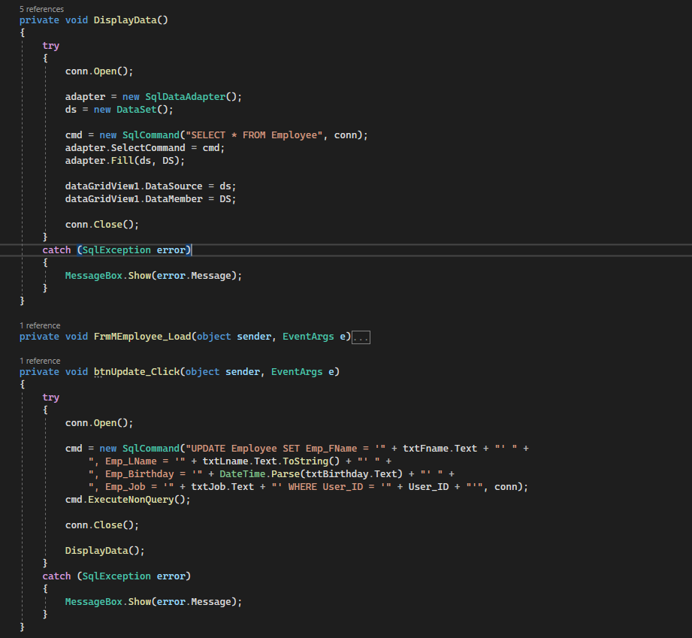

Reports Generated by the System

Report generated for the manager (filtered to only show memory trainings):
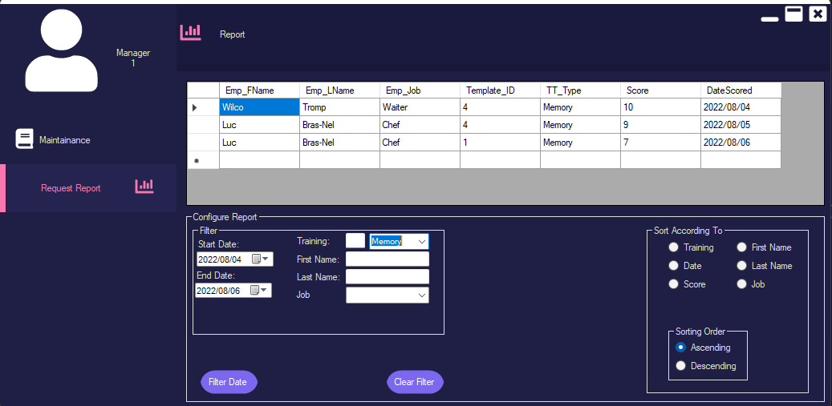
Report generated for the employee (Sorted descending according to date):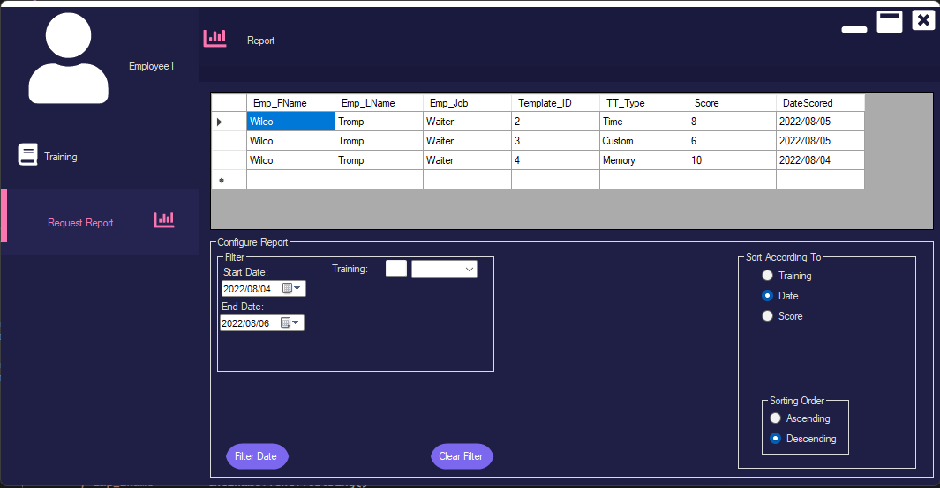

User Manual
USER-MANUAL  Girlyy Games Development | Waiter training application  – For burgeraholics  Group 20  Almero Jansen van Vuuren – 35202734  Lincoln van Zyl – 35029617  Melissa Roodt – 33509735  Luc Bras-Nel – 37649523  Wilco Tromp – 34531033

Table of Contents
Technical requirements 13
Getting the system installed 13
Launching the application 13
Manager 14
Logging in 14
Maintaining Employees 15
Adding New Employees 16
Deleting an Employee Record. 17
Maintaining Training Templates 17
Requesting Reports 19
Employee 21
Logging in 21
Using Training Tests 21
• Time training has a progress bar that shows you how much time you have left 22
• When submit is clicked then the score gets saved to a database. 23
Requesting Reports 23
Admin 25
Logging in 25
Dashboard 25
Maintaining Managers 26
Adding New Managers 27
Deleting a Manager Record. 27

Technical requirements
- 1.8 GHz or faster 64-bit processor, Quad-core or better.
- Minimum of 4 GB of RAM. 8 GB of RAM recommended
- Hard disk space: Minimum of 20 GB. (This includes the space required for Visual studio)
- Video card that supports a minimum display resolution of WXGA (1366 by 768);

Getting the system installed
- Download and install Visual Studio with the following Workloads (If Visual Studio is already installed with the correct workloads skip to step 2):
  - Azure development
  - .NET desktop Development
  - Universal Windows Platform development
  - Data storage and processing
- Download the Burgeraholics zip file.
- Navigate to the location the zip file was downloaded to.
- Unzip the zip file
- Double left click setup
  - You will be presented with a warning screen.
  - Click on the Install button at bottom right of the warning screen.
- After the setup has been completed. A desktop shortcut icon will be created automatically.

Launching the application
- After the setup has been completed, the application will automatically run for the first time.
- To run it again after closing. Double left click on the desktop shortcut icon.

Manager

Logging in
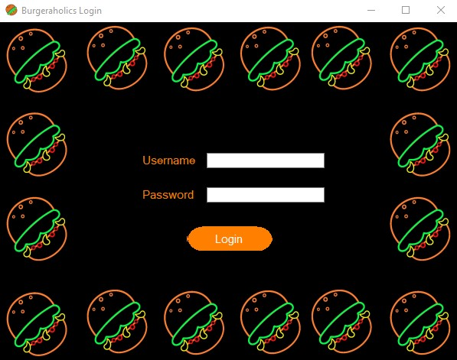
- Enter your username and password into the corresponding text areas.
- Click on the Login button.

Maintaining Employees
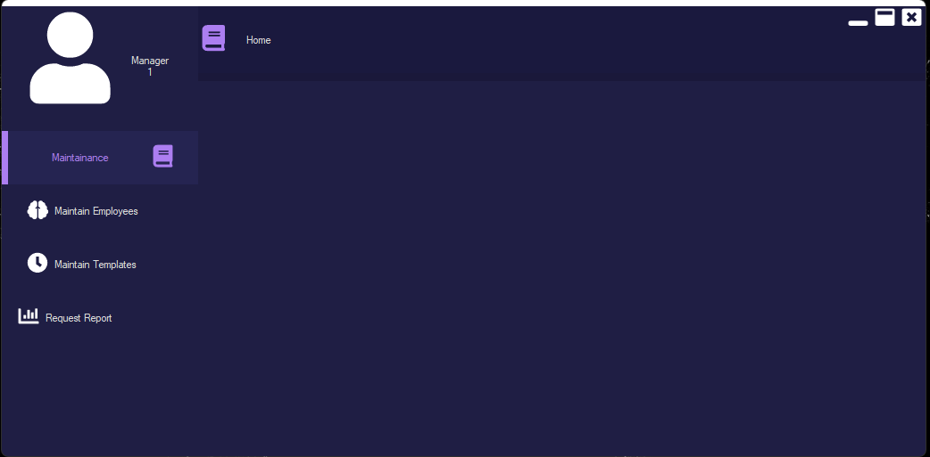
- Click on Maintenance
- Click on Maintain Employees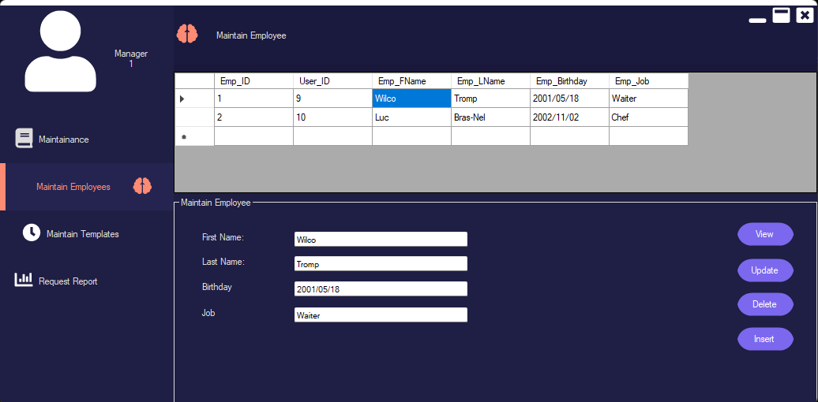
- Click on View
- Then click on the Employees name that you want to edit
- In the text areas change/edit the necessary information

Adding New Employees
- Enter the Details of the new Employee into the text areas.
- Click on the Insert button
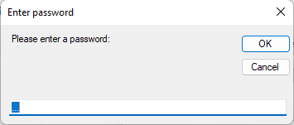
- Allow the new Employee to enter their password.

Deleting an Employee Record.
- Click on the employee’s name of the employee record that you want to delete.
- Click on the Delete button to delete the record

Maintaining Training Templates
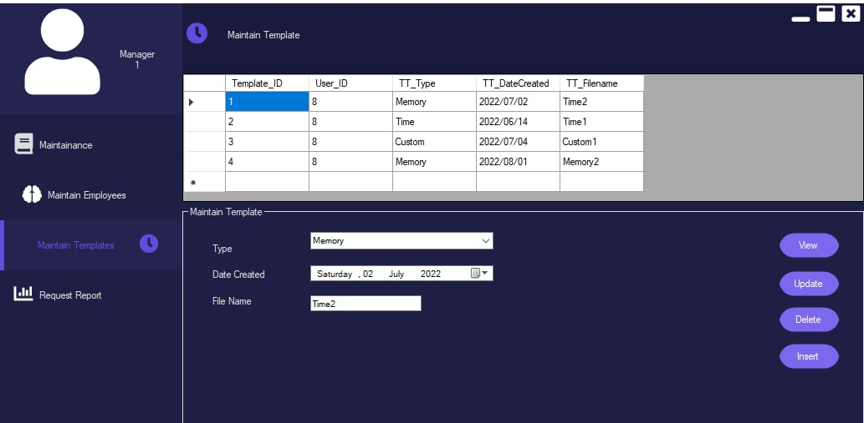
- Clicking on the data grid view you can select the data and it will display in the information in the in the allocated area below.
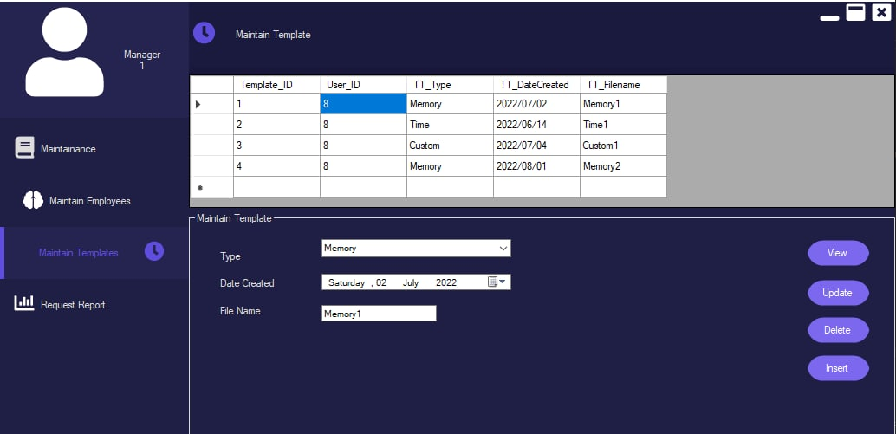
- The same as the top just showing that it triggers the
- Insert is entering new data into database.
- Update just updating the existing information in the database.
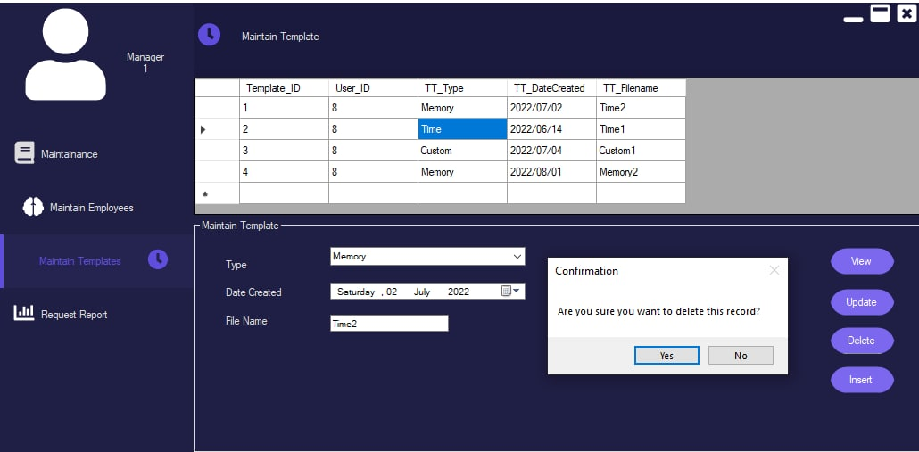
- Delete button first asks if you are sure you want to delete the information and then if the user accepts, then the data gets removed from the data base.

Requesting Reports
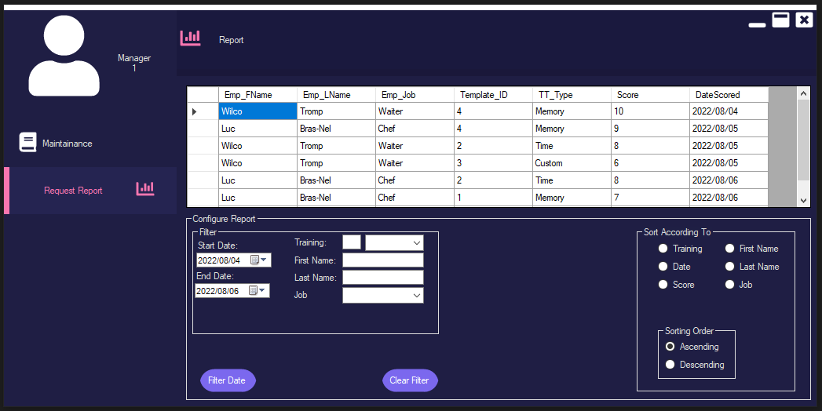
- The report window allows the manager to see the score of each employee for each training template and on which day it was completed

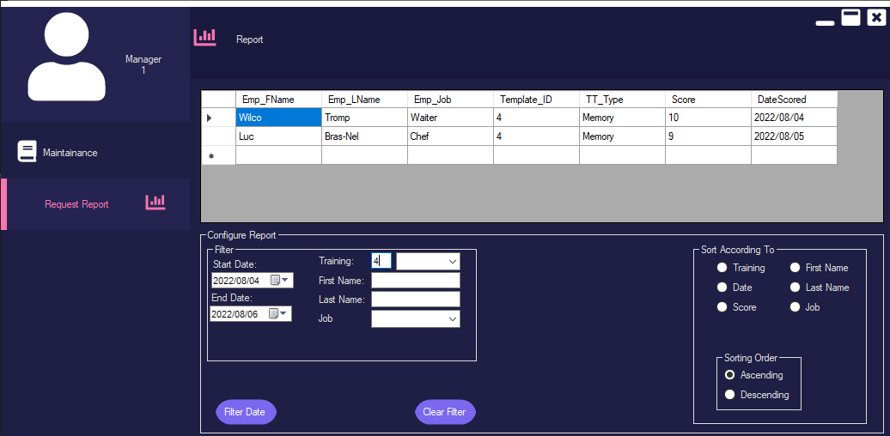
- This window also allows the manager to filter the scores according to the names of the employees, their job positions, which training they completed, or the date on which they completed it.
- This is done editing the values in one of the fields for immediate sorting, or in the case of the dates, editing the dates and clicking the button “filter dates.”

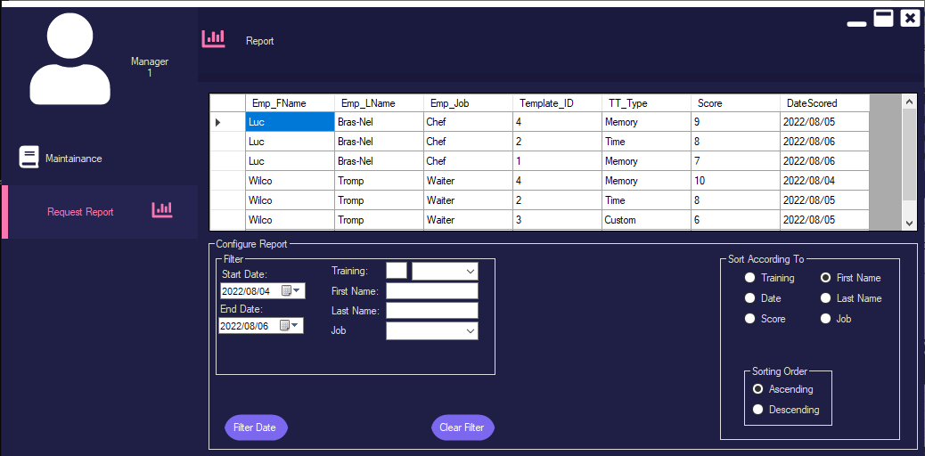
- Another feature is sorting the data according to any of the fields. This is done by just clicking on the radio button with the name of the field that you want to sort by.
- You can also change the order of sorting by either clicking on “ascending” or “descending” (it is set to ascending by default).

Employee

Logging in
- Enter your username and password into the corresponding text areas.
- Click on the Login button.

Using Training Tests
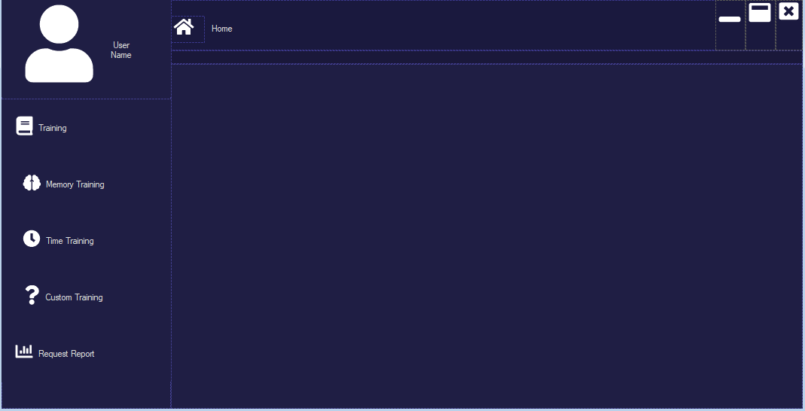
- When employee login they will see this screen and must choose which training type they want to do, and they can request a report after the training.
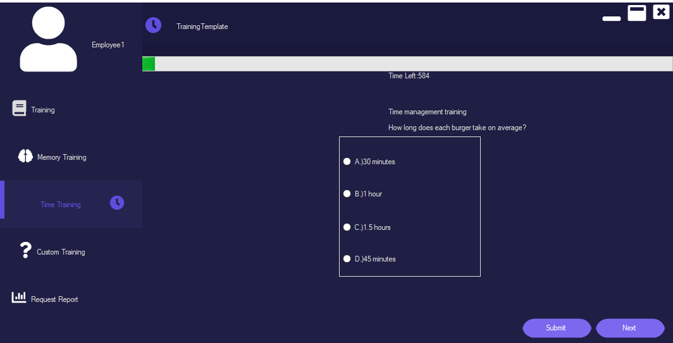

Time training has a progress bar that shows you how much time you have left
- Pressing the next button will save your answer and update your score if you have the correct answer, while going to the next question.
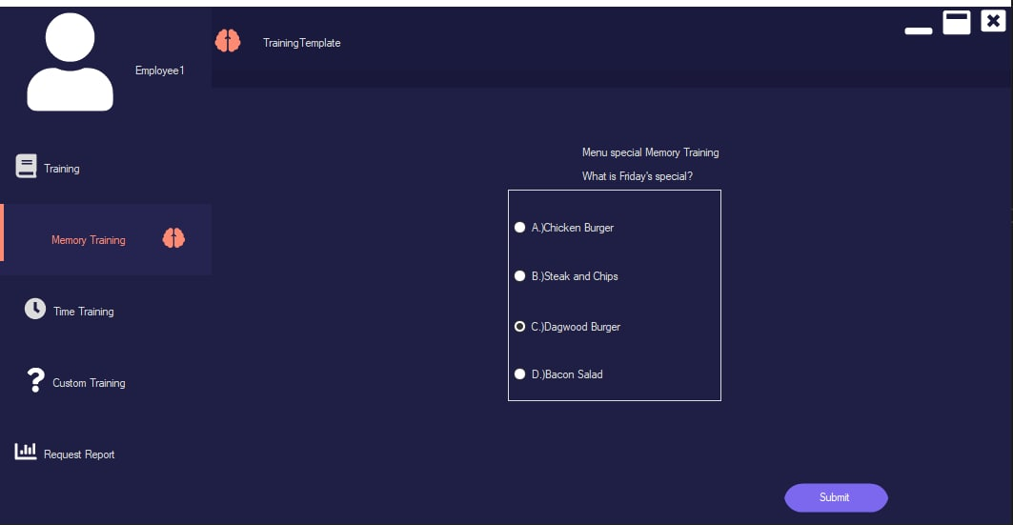
- When going through training when reaching the last question, the next button disappears and only the submit button becomes available.
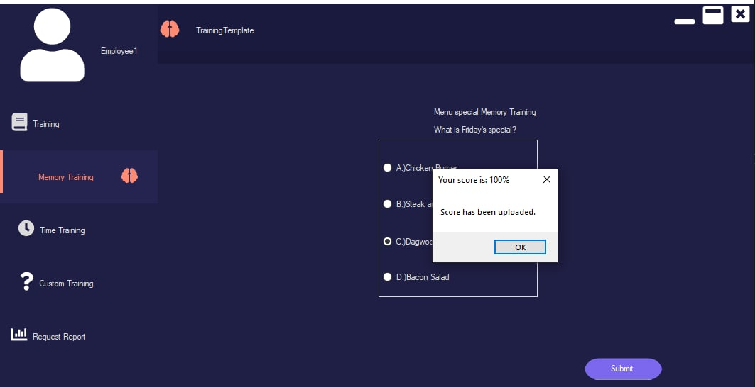

When submit is clicked then the score gets saved to a database.
- And the trainee gets to see how well they did in their test.

Requesting Reports
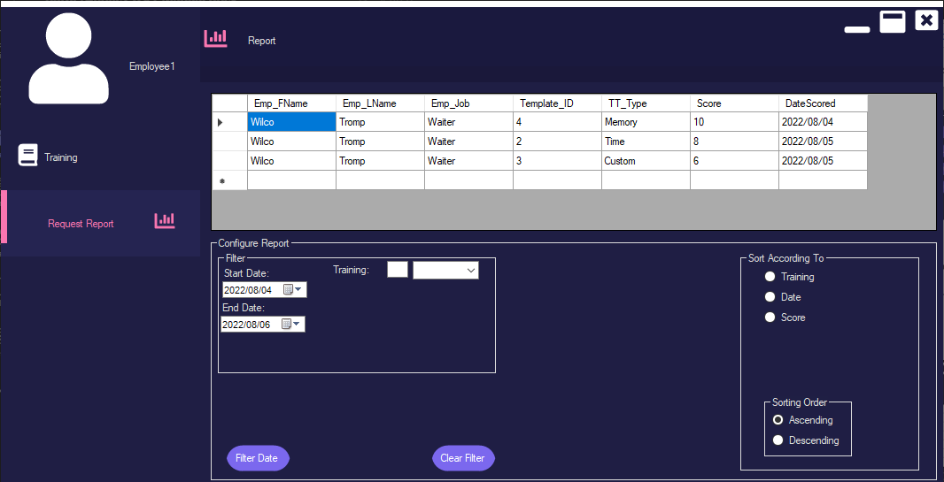
- This screen allows the employee to view their past scores, with the training template they did and the day they did it on.\

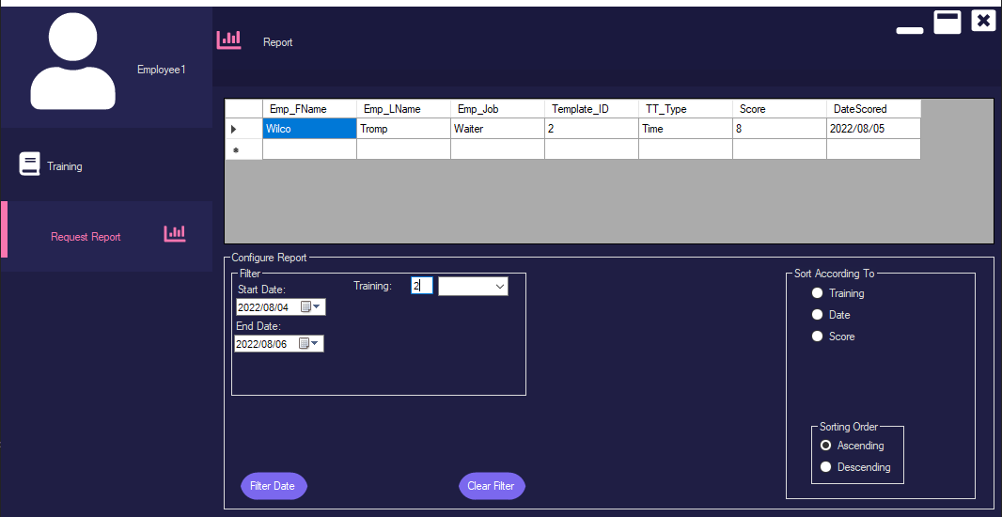
- It also allows the employee to filter their scores according to which training they completed, or the date on which they completed it.
- This is done editing the values in one of the fields for immediate sorting, or in the case of the dates, editing the dates and clicking the button “filter dates.”

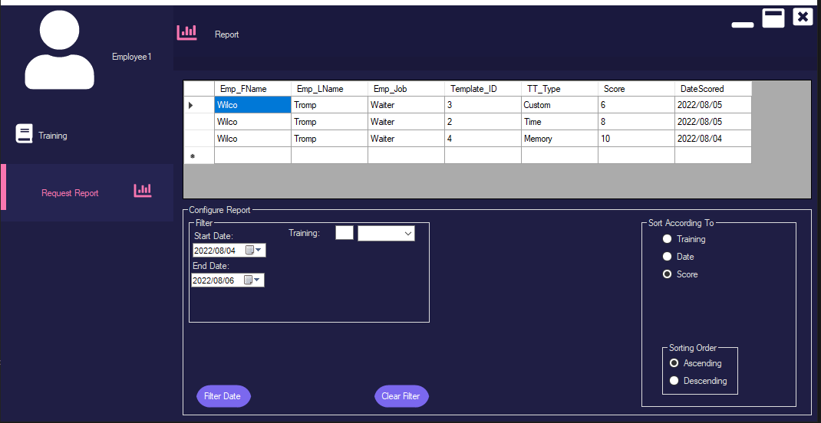
- Another feature is sorting the data according to any of the fields. This is done by just clicking on the radio button with the name of the field that you want to sort by.
- You can also change the order of sorting by either clicking on “ascending” or “descending” (it is set to ascending by default).

Admin

Logging in
- Enter your username and password into the corresponding text areas.
- Click on the Login button.

Dashboard
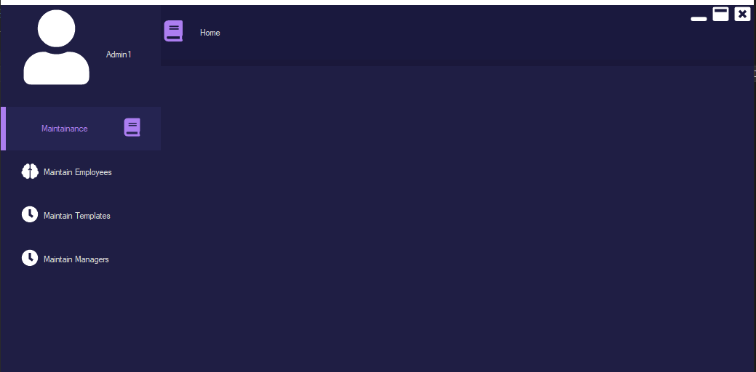
- See Manager on how to maintain employees and templates

Maintaining Managers
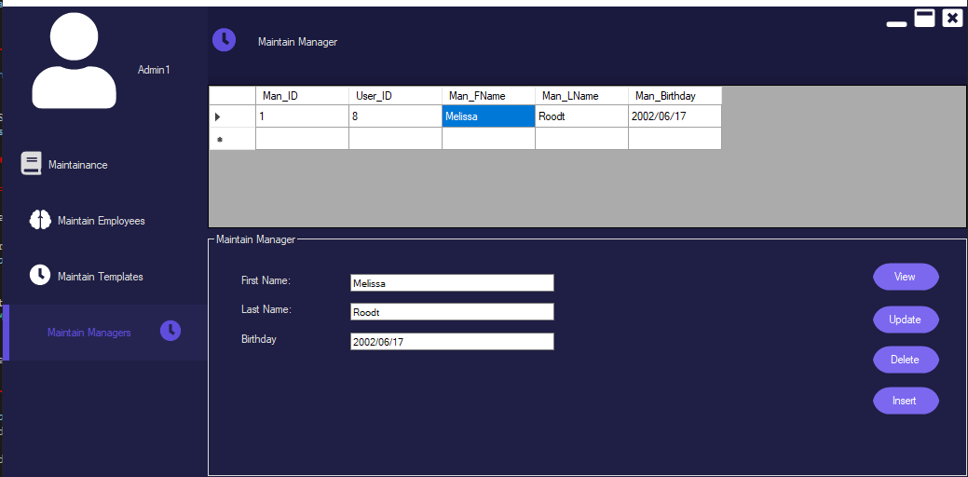
- Click on Maintenance
- Click on Maintain Managers
- Click on View
- Then click on the Manager’s name that you want to edit
- In the text areas change/edit the necessary information

Adding New Managers
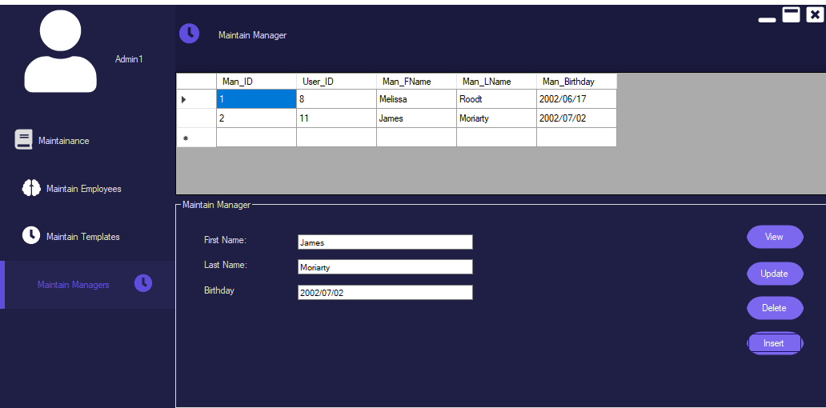
- Enter the Details of the new Manager into the text areas.
- Click on the Insert button
- Allow the new Manager to enter their password.

Deleting a Manager Record.
- Click on the Manager’s name of the Manager record that you want to delete.
- Click on the Delete button to delete the record

Detail Dairy
Almero Jansen van Vuuren 35202734 and Lincoln van Zyl 35029617
We worked on the project on Saturday (2022/09/10). We started early but loadshedding interrupted our work. We continued into after midday till early night when the loadshedding caused problems once more.
Sunday (2022/09/11) we started working from midday to early night.
Created the code for the training, loading the questions from the text files stored references that are in the database, loading the answers from the said text files.
Created the code to calculate how many questions there are per file.
Created the SQL code for inserting the users score from the training into a database.
We created the SQL code for the Training templates to insert new templates, updating templates and deleting templates.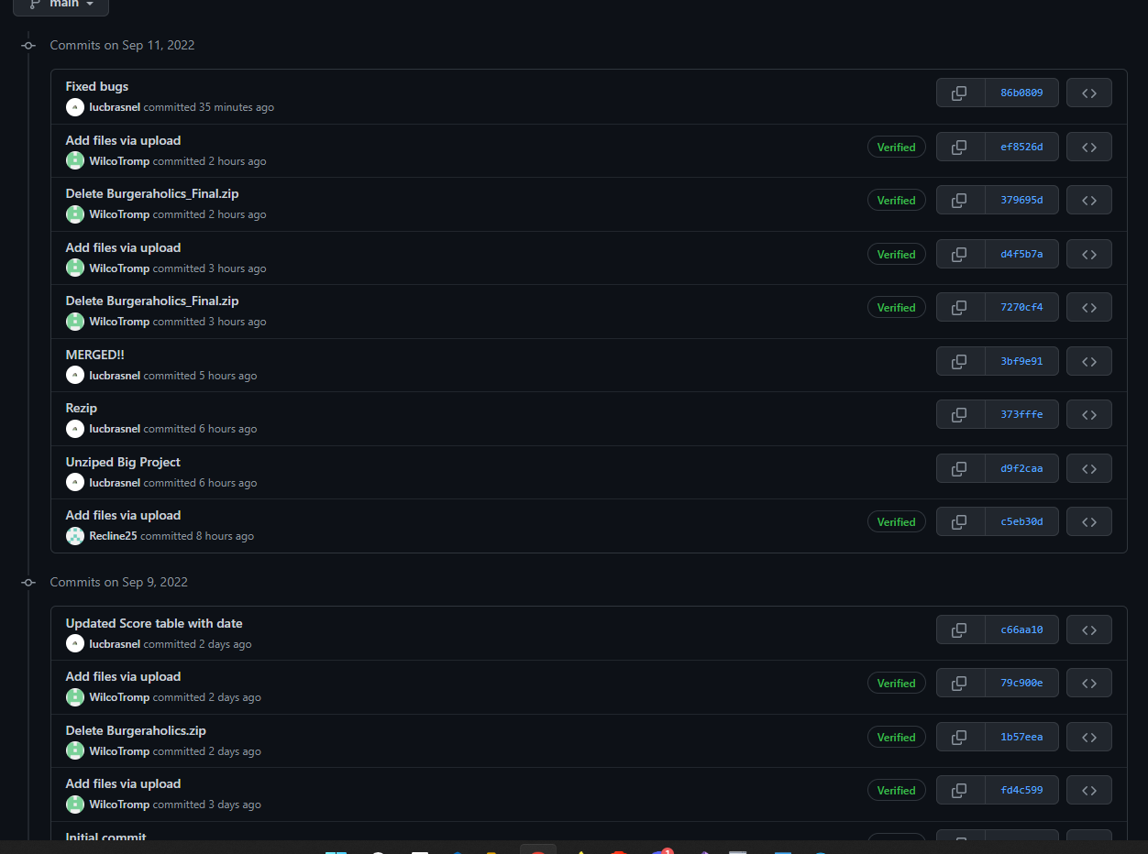
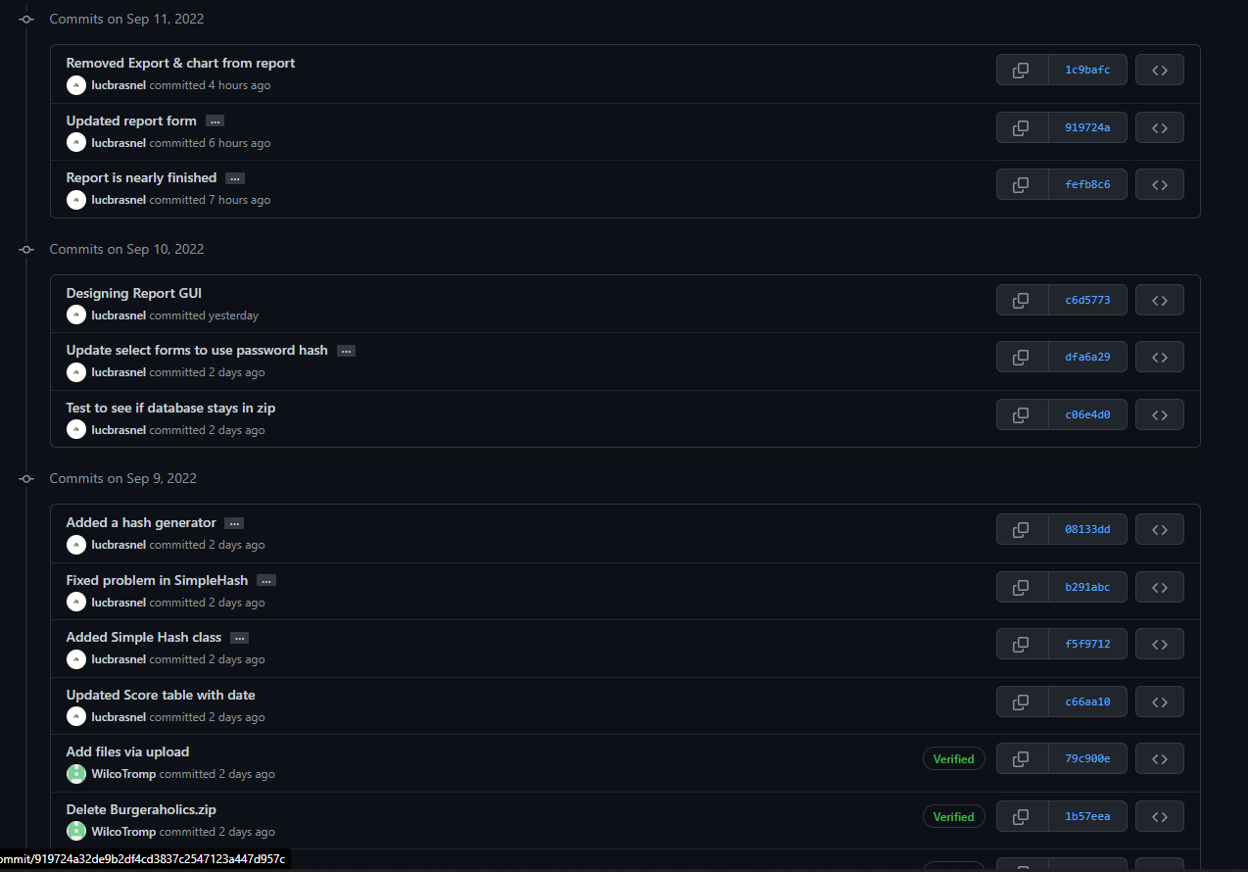

** END OF DOCUMENT **

